NAME: EVALYNE KAGENDO MURIMI
COURSE: DSA 1080
ID NUMBER: 675940
DSA PROJECT: TRAFFIC ACCIDENT SEVERITY PREDICTION FINAL REPORT.
1. INTRODUCTION:
This project aims to predict the severity of a traffic accident on a scale of 0 to 1, where 1 indicates a severe accident, and 0 indicates a non-severe accident. This is done based on environmental, driver, road, and time-related features, driven by the use of machine learning (Random forest)
2. DATASET DESCRIPTION:
Dataset: 840 rows, 14 columns from dataset_traffic_accident_prediction1.csv. found on Kaggle.
The dataset contains:
- Environmental factors: weather, lighting, visibility
- Road conditions: road type, surface, traffic density
- Driver and vehicle information
- Time-related features
Target variable: Accident (0 = Not Severe, 1 = Severe)
METHODOLOGY USED:
Week 1: Data loading and inspection
Week 2: Data cleaning & exploratory analysis
Week 3: Feature engineering, encoding, correlation, VIF, chi-square, train-test split
Week 4: Model building using RandomForest
Week 5: Model evaluation using accuracy, precision, recall, F1-score, and confusion matrix
Feature Selection Techniques
- Correlation Analysis– to identify highly correlated numerical features
- VIF (Variance Inflation Factor)– detect multicollinearity
- Chi-Square Test – identify significant categorical features
Model Used: Logistic Regression
Logistic Regression was chosen because:
- It is ideal for binary classification problems
- It is interpretable (coefficients show feature importance)
- Performs well with encoded categorical variables
ANALYSIS
It included the following:
Accuracy-
Precision-
Recall-
F1-score-
The model achieved an accuracy of 0.68, indicating strong performance in predicting accident severity.
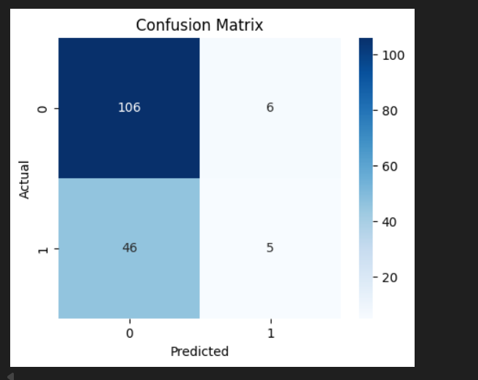

KEY FINDINGS.
Certain weather and roads, like rainy days, increase the severity of an accident.
Random Forest identified the most important features.
CONCLUSION:
Random Forest successfully predicted accident severity with good performance, and feature selection improved the stability of the model and its interpretation.

